**BIONIC ENGINEERS**

Bengaluru, Karnataka, India



AN INTERNSHIP REPORT

ON

“Website For Quient Trainings Pvt Ltd”

#### Bachelor of Engineering

#### In

#### Computer Science and Engineering

#### Submitted by: ABHISHEK M DAMBALMATH(1KT18CS003)

#### 

#### 

**COLLEGE- SRI KRISHNA INSTITUTE OF TECHNOLOGY**

#### 2020-2021

## **ABOUT THE COMPANY**

IC Solution (ICS) is a digital service provider that aims to provide software, designing and marketing solutions to individuals and businesses. At ICS, we believe that service and quality is the key to success

We provide all kinds of technological and designing solutions from Billing Software

to Web Designs or any custom demand that you may have. Experience the service

like none other!

Some of our services include:

Development - We develop responsive, functional and super-fast websites.

We keep User Experience in mind while creating websites. A website should load

quickly and should be accessible even on a small view-port and slow internet

connection.

Mobile Application - We offer a wide range of professional Android, iOS & Hybrid

app development services for our global clients, from a start up to a large enterprise.

Design - We offer professional Graphic design, Brochure design & Logo design.

We are experts in crafting visual content to convey the right message to the customers.

Consultancy - We are here to provide you with expert advice on your design

and development requirement.

Videos - We create a polished professional video that impresses your audience.

**TABLE OF CONTENTS**

Table of contents i

Overview of the Project 1

About Quient Training Pvt Ltd 2

Objectives and Training Activities by Quient Group 3

Tools Used 4

Implementation 5

Snapshots 21

Bibliography 28

## **OVERVIEW OF THE PROJECT**

## **Project Name:** Quient Trainings Pvt Ltd

**Team Members:** Abhishek M Dambalmath

Chaitra V

Chandana M

Sree Rakshitha Lahari

## This project is based on Web Development And its Applications. The main objective of this project is to learn the implementation of HTML, CSS and JavaScript. The basic webpage of this project is created using HTML and styling of the webpage is done using CSS. And backend is done by using php.

Quient training is an enthusiastic group intended to train students in colleges that are denied the privilege of Placement training. A group of Enthusiasts now have a vision of training students that don’t have access to placement training that can help them get placed, and thereby build their future.

## This webpage is about one of the greatest companies of all time

## **ABOUT QUIENT TRAININGS Pvt Ltd**

Quient training is an enthusiastic group intended to train students in colleges that are denied the privilege of Placement training, A group of Enthusiasts now have a vision of training students that don’t have access to placement training that can help them get placed, and thereby build their future.

**Why is Placement training important:**

Placement training plays a major role in shaping up the career goals of students. It is the dream of every engineering student to get placed in a top organization visiting their campus for recruitment. Keeping this key aspect into consideration, it is realized that training is important for engineering students to enhance their employability skills and achieve good placement in various Industries.

At present, the competition for employment is increasing every day and placement has become a challenging task. Training students and equipping them with life skills has become an important responsibility of the institution. Along with technical expertise, the development of a holistic personality is also necessary.

**Objectives and Training Activities by Origin Group**

* Prime objectives of the Training Cell
* To look for 100% employment for all students.
* To recognize the core competencies of the students.
* To train the students to meet the expectations of the industry through our Career

Development Programmes.

* To build confidence in students and develop the right attitude in them and
* To enhance their communication skills.
* Training Activities
* Create awareness about “career planning" and "career mapping" among the

students.

* Equip the student with life skills.
* Train the students on “Personality development".
* Organize Various Training Programmes to train the students in the areas of
* Quantitative Aptitude, Logical Reasoning and Verbal reasoning through the

reputed external training organizations and in-house trainers.

* Train the students through Mock Interviews to perform well in the professional

interviews as per the expectations of the corporate world.

* Train the students on group discussion techniques
* Conduct online tests and written aptitude tests.

# **TOOLS USED**

### **Software Requirements**

* Visual Studio Code 2019.
* Google Chrome or Microsoft Edge of latest version.
* Front End: HTML, CSS, JS (optional)
* Linux 7.1 or Windows XP/7/8/10 OS or Mac OS

### **Hardware Requirements**

* Pentium 200-MHz computer with a minimum of 64 MB of RAM (128 MB of RAM recommended).
* Monitor with a refresh rate of at least 40Hz for a smooth GUI experience (optional).

# **IMPLEMENTATION**

**FRONT END**

# **Source Code (html):**

**LANDING PAGE.HTML**

**LOGIN.PHP**

<?php include('server.php') ?>

<!DOCTYPE html>

<html>

<head>

<title>Registration system PHP and MySQL</title>

<link rel="stylesheet" type="text/css" href="style.css">

</head>

<body>

<div class="header">

<h2>Login</h2>

</div>

<form method="post" action="login.php">

<?php include('error.php'); ?>

<div class="input-group">

<label>Username</label>

<input type="text" name="username" >

</div>

<div class="input-group">

<label>Password</label>

<input type="password" name="password">

</div>

<div class="input-group">

<button type="submit" class="btn" name="login_user">Login</button>

</div>

<p>

Not yet a member? <a href="register.php">Sign up</a>

</p>

</form>

</body>

</html>

**INDEX.PHP**

<?php

session_start();

if (!isset($_SESSION['username'])) {

$_SESSION['msg'] = "You must log in first";

header('location: login.php');

}

if (isset($_GET['logout'])) {

session_destroy();

unset($_SESSION['username']);

header("location: login.php");

}

?>

<html lang="en">

<head>

<meta charset="utf-8">

<meta name="viewport" content="width=device-width, initial-scale=1, shrink-to-fit=no">

<meta name="description" content="">

<meta name="author" content="P">

<link href="https://fonts.googleapis.com/css?family=Poppins:100,200,300,400,500,600,700,800,900&display=swap" rel="stylesheet">

<title>Quient Trainings</title>

<link rel="stylesheet" type="text/css" href="assets/css/bootstrap.min.css">

<link rel="stylesheet" type="text/css" href="assets/css/font-awesome.css">

<link rel="stylesheet" href="assets/css/tempalment-lava.css">

<link rel="stylesheet" href="assets/css/owl-carousel.css">

</head>

<body>

<!-- ** Preloader Start ** -->

<div id="preloader">

<div class="jumper">

<div></div>

<div></div>

<div></div>

</div>

</div>

<!-- ** Preloader End ** -->

<!-- ** Header Area Start ** -->

<header class="header-area header-sticky">

<div class="container">

<div class="row">

<div class="col-12">

<nav class="main-nav">

<!-- ** Logo Start ** -->

<a href="index.html" class="logo">

Quient Trainings

</a>

<!-- ** Logo End ** -->

<!-- ** Menu Start ** -->

<ul class="nav">

<li class="scroll-to-section"><a href="#welcome" class="menu-item">Home</a></li>

<li class="scroll-to-section"><a href="#about" class="menu-item">About</a></li>

<li class="scroll-to-section"><a href="#testimonials" class="menu-item">Testimonials</a>

</li>

<li class="scroll-to-section"><a href="#about" class="menu-item">Gallery</a></li>

<li class="scroll-to-section"><a href="#contact-us" class="menu-item">Contact Us</a></li>

</ul>

<a class='menu-trigger'>

<span>Menu</span>

</a>

<!-- ** Menu End ** -->

</nav>

</div>

</div>

</div>

</header>

<!-- ** Header Area End ** -->

<!-- ** Welcome Area Start ** -->

<div class="welcome-area" id="welcome">

<!-- ** Header Text Start ** -->

<div class="header-text">

<div class="container">

<div class="row">

<div class="left-text col-lg-6 col-md-12 col-sm-12 col-xs-12"

data-scroll-reveal="enter left move 30px over 0.6s after 0.4s">

<h1> Best place to Learn and get <em> PLACED </em></h1>

<p> <a href="#">Quient Trainings </a> provides best in class training <a href="#"></a> for placements

it comprises of entusiastic people who vision to provide and promise 100% placement through their training and thereby build students future </p>

<a href="#about" class="main-button-slider">KNOW US BETTER</a>

</div>

</div>

</div>

</div>

<!-- ** Header Text End ** -->

</div>

<!-- ** Welcome Area End ** -->

<!-- ** Features Big Item Start ** -->

<section class="section" id="about">

<div class="container">

<div class="row">

<div class="col-lg-4 col-md-6 col-sm-12 col-xs-12"

data-scroll-reveal="enter left move 30px over 0.6s after 0.6s">

<div class="features-item">

<div class="features-icon">

<h2>01</h2>

<img src="assets/images/features-icon-3.png" alt="">

<h4>why placement training important ? </h4>

<li>Placement training plays a major role in shaping up the career goals of students</li>

<li>training is important to enhance student's employability skills</li>

<a href="assets/images/important.png" class="main-button">

Read More

</a>

</div>

</div>

</div>

<div class="col-lg-4 col-md-6 col-sm-12 col-xs-12"

data-scroll-reveal="enter bottom move 30px over 0.6s after 0.4s">

<div class="features-item">

<div class="features-icon">

<h2>02</h2>

<img src="assets/images/features-icon-2.png" alt="">

<h4> Training Activities of placement cell</h4>

<ol>

<li> •create awareness about "career planning"</li>

<li> •equipstudents with life skills.</li>

<li> •Train students on "personality developement"</li>

<a href="assets/images/objective.png" class="main-button">

Discover More

</a>

</div>

</div>

</div>

<div class="col-lg-4 col-md-6 col-sm-12 col-xs-12"

data-scroll-reveal="enter right move 30px over 0.6s after 0.4s">

<div class="features-item">

<div class="features-icon">

<h2>03</h2>

<img src="assets/images/features-icon-1.png" alt="">

<h4> Prime Objective of training cell</h4>

<p><li> •to look for 100% employibility</li>

<li> •to recognize core competence of students </li>

<li> •to build confidence and develope right attitude among students</li></p>

<a href="assets/images/training.png" class="main-button">

More Detail

</a>

</div>

</div>

</div>

</div>

</div>

</section>

<!-- ** Features Big Item End ** -->

<div class="left-image-decor"></div>

<!-- ** Features Big Item Start ** -->

<section class="section" id="promotion">

<div class="container">

<div class="row">

<div class="left-image col-lg-5 col-md-12 col-sm-12 mobile-bottom-fix-big"

data-scroll-reveal="enter left move 30px over 0.6s after 0.4s">

<img src="assets/images/logo1.jpeg" class="rounded img-fluid d-block mx-auto" alt="App">

</div>

<div class="right-text offset-lg-1 col-lg-6 col-md-12 col-sm-12 mobile-bottom-fix">

<ul>

<li data-scroll-reveal="enter right move 30px over 0.6s after 0.4s">

<img src="assets/images/collage.png" alt="">

<div class="text">

<h4>Collages</h4>

<p>There are total of 75+ collages in collabration with our training unit <a

rel="nofollow" href="#" target="_parent">Click here</a>to get the list of collages</p>

</div>

</li>

<li data-scroll-reveal="enter right move 30px over 0.6s after 0.5s">

<img src="assets/images/students.png" alt="">

<div class="text">

<h4>Students </h4>

<p>Total of 1000+ studets have already been trainined by our professionals,You can click <a rel="nofollow"

href="assets/images/gallery.png">here</a> to have a glimpse of the training </p>

</div>

</li>

<li data-scroll-reveal="enter right move 30px over 0.8s after 0.8s">

<img src="assets/images/company.png" alt="">

<div class="text">

<h4> Companies</h4>

<p>We Have tied up with numerous companies ,that provides job offers after completion of training </p>

</div>

</li>

</ul>

</div>

</div>

</div>

</section>

<!-- ** Features Big Item End ** -->

<div class="right-image-decor"></div>

<!-- ** Testimonials Starts ** -->

<section class="section" id="testimonials">

<div class="container">

<div class="row">

<div class="col-lg-8 offset-lg-2">

<div class="center-heading">

<h2>What They Think <em>About Us</em></h2>

<p>Being one of the best placement training companies out there ,we want you to know what our students thinks about us.

</p>

</div>

</div>

<div class="col-lg-10 col-md-12 col-sm-12 mobile-bottom-fix-big"

data-scroll-reveal="enter left move 30px over 0.6s after 0.4s">

<div class="owl-carousel owl-theme">

<div class="item service-item">

<div class="author">

<i><img src="assets/images/author12.png" alt="Author One"></i>

</div>

<div class="testimonial-content">

<ul class="stars">

<li><i class="fa fa-star"></i></li>

<li><i class="fa fa-star"></i></li>

<li><i class="fa fa-star"></i></li>

<li><i class="fa fa-star"></i></li>

<li><i class="fa fa-star"></i></li>

</ul>

<h4>Darshan</h4>

<p>“Being an average student to get placed in Hashdien, Quient trainings has helped me throughtout the process of placement and now i'm living happily .

”</p>

<span>Web Developer</span>

</div>

</div>

<div class="item service-item">

<div class="author">

<i><img src="assets/images/author11.png" alt="Second Author"></i>

</div>

<div class="testimonial-content">

<ul class="stars">

<li><i class="fa fa-star"></i></li>

<li><i class="fa fa-star"></i></li>

<li><i class="fa fa-star"></i></li>

<li><i class="fa fa-star"></i></li>

<li><i class="fa fa-star"></i></li>

</ul>

<h4>Anjali</h4>

<p>“ I don't know how to thank them ,i can only say they are the best.i have visited many training centers but this was the best of all of them

”</p>

<span>Web Analyst</span>

</div>

</div>

<div class="item service-item">

<div class="author">

<i><img src="assets/images/author3.jpg" alt="Author Third"></i>

</div>

<div class="testimonial-content">

<ul class="stars">

<li><i class="fa fa-star"></i></li>

<li><i class="fa fa-star"></i></li>

<li><i class="fa fa-star"></i></li>

</ul>

<h4>Shreya</h4>

<p>“Because of the quality of training from quient , i am working as a software

developer and leading my life happily , all credit goes to Quient Training

”</p>

<span>Software Developer</span>

</div>

</div>

<div class="item service-item">

<div class="author">

<i><img src="assets/images/author4.jfif" alt="Fourth Author"></i>

</div>

<div class="testimonial-content">

<ul class="stars">

<li><i class="fa fa-star"></i></li>

<li><i class="fa fa-star"></i></li>

<li><i class="fa fa-star"></i></li>

<li><i class="fa fa-star"></i></li>

</ul>

<h4>Ram</h4>

<p>"unemployment is worst , but thanks to quient trainings they helped me to get of it,

and i highly recommend everyone to be a part of quient trainings

"</p>

<span>Data Scientist</span>

</div>

</div>

</div>

</div>

</div>

</div>

</section>

<!-- ** Testimonials Ends ** -->

<!-- ** Footer Start ** -->

<footer id="contact-us">

<div class="container">

<div class="footer-content">

<div class="row">

<!-- ** Contact Form Start ** -->

<div class="col-lg-6 col-md-12 col-sm-12">

<div class="contact-form">

<form id="contact" action="" method="post">

<div class="row">

<div class="col-md-6 col-sm-12">

<fieldset>

<input name="name" type="text" id="name" placeholder="Full Name" required=""

style="background-color: rgba(250,250,250,0.3);">

</fieldset>

</div>

<div class="col-md-6 col-sm-12">

<fieldset>

<input name="email" type="text" id="email" placeholder="E-Mail Address"

required="" style="background-color: rgba(250,250,250,0.3);">

</fieldset>

</div>

<div class="col-lg-12">

<fieldset>

<textarea name="message" rows="6" id="message" placeholder="Your Message"

required="" style="background-color: rgba(250,250,250,0.3);"></textarea>

</fieldset>

</div>

<div class="col-lg-12">

<fieldset>

<button type="submit" id="form-submit" class="main-button">Send Message

Now</button>

</fieldset>

</div>

</div>

</form>

</div>

</div>

<!-- ** Contact Form End ** -->

<div class="right-content col-lg-6 col-md-12 col-sm-12">

<h2>More About <em>Quient Trainings</em></h2>

<p> We provide wide variety of trainings based on your choice of company , we are purpose built to serve

our students to satisfly and help them achieve thier goals

<br><br>If you want to know more <a

rel="nofollow" href="assets/images/contact.png" target="_parent"> <h4><em>Contact Us on <li><a href="#"><i class="fa fa-whatsapp"> +91-9263526252</i></a></li></em></a></h4> and get the Quotation.

</p>

<ul class="social">

<li><a href="#"><i class ="fa fa-facebook"></i></a></li>

<li><a href="#"><i class ="fa fa-twitter"></i></a></li>

<li><a href="#"><i class ="fa fa-linkedin"></i></a></li>

<p><button> <a href="index.php?logout='1'" style="color: red;">logout</a> </p></button>

</div>

</div>

</div>

<div class="row">

<div class="col-lg-12">

<div class="sub-footer">

<p>Copyright &copy; Quient Trainings Pvt ltd

| Designed by <a rel="nofollow" href="#">P</a></p>

</div>

</div>

</div>

</div>

</footer>

<!-- jQuery -->

<script src="assets/js/jquery-2.1.0.min.js"></script>

<!-- Bootstrap -->

<script src="assets/js/popper.js"></script>

<script src="assets/js/bootstrap.min.js"></script>

<!-- Plugins -->

<script src="assets/js/owl-carousel.js"></script>

<script src="assets/js/scrollreveal.min.js"></script>

<script src="assets/js/waypoints.min.js"></script>

<script src="assets/js/jquery.counterup.min.js"></script>

<script src="assets/js/imgfix.min.js"></script>

<!-- Global Init -->

<script src="assets/js/custom.js"></script>

</body>

</html>

**REGISTRATION.PHP**

<?php include('server.php') ?>

<!DOCTYPE html>

<html>

<head>

<title>Registration system PHP and MySQL</title>

<link rel="stylesheet" type="text/css" href="style.css">

</head>

<body>

<div class="header">

<h2>Register</h2>

</div>

<form method="post" action="register.php">

<?php include('error.php'); ?>

<div class="input-group">

<label>Username</label>

<input type="text" name="username" value="<?php echo $username; ?>">

</div>

<div class="input-group">

<label>Email</label>

<input type="email" name="email" value="<?php echo $email; ?>">

</div>

<div class="input-group">

<label>Password</label>

<input type="password" name="password_1">

</div>

<div class="input-group">

<label>Confirm password</label>

<input type="password" name="password_2">

</div>

<div class="input-group">

<button type="submit" class="btn" name="reg_user">Register</button>

</div>

<p>

Already a member? <a href="login.php">Sign in</a>

</p>

</form>

</body>

</html>

**SERVER.PHP**

<?php

session_start();

// initializing variables

$username = "";

$email = "";

$errors = array();

// connect to the database

$db = mysqli_connect('localhost', 'root', '', 'registration');

// REGISTER USER

if (isset($_POST['reg_user'])) {

// receive all input values from the form

$username = mysqli_real_escape_string($db, $_POST['username']);

$email = mysqli_real_escape_string($db, $_POST['email']);

$password_1 = mysqli_real_escape_string($db, $_POST['password_1']);

$password_2 = mysqli_real_escape_string($db, $_POST['password_2']);

// form validation: ensure that the form is correctly filled ...

// by adding (array_push()) corresponding error unto $errors array

if (empty($username)) { array_push($errors, "Username is required"); }

if (empty($email)) { array_push($errors, "Email is required"); }

if (empty($password_1)) { array_push($errors, "Password is required"); }

if ($password_1 != $password_2) {

array_push($errors, "The two passwords do not match");

}

// first check the database to make sure

// a user does not already exist with the same username and/or email

$user_check_query = "SELECT * FROM users WHERE username='$username' OR email='$email' LIMIT 1";

$result = mysqli_query($db, $user_check_query);

$user = mysqli_fetch_assoc($result);

if ($user) { // if user exists

if ($user['username'] === $username) {

array_push($errors, "Username already exists");

}

if ($user['email'] === $email) {

array_push($errors, "email already exists");

}

}

// Finally, register user if there are no errors in the form

if (count($errors) == 0) {

$password = md5($password_1);//encrypt the password before saving in the database

$query = "INSERT INTO users (username, email, password)

VALUES('$username', '$email', '$password')";

mysqli_query($db, $query);

$_SESSION['username'] = $username;

$_SESSION['success'] = "You are now logged in";

header('location: index.php');

}

}

// ...

// ...

// LOGIN USER

if (isset($_POST['login_user'])) {

$username = mysqli_real_escape_string($db, $_POST['username']);

$password = mysqli_real_escape_string($db, $_POST['password']);

if (empty($username)) {

array_push($errors, "Username is required");

}

if (empty($password)) {

array_push($errors, "Password is required");

}

if (count($errors) == 0) {

$password = md5($password);

$query = "SELECT * FROM users WHERE username='$username' AND password='$password'";

$results = mysqli_query($db, $query);

if (mysqli_num_rows($results) == 1) {

$_SESSION['username'] = $username;

$_SESSION['success'] = "You are now logged in";

header('location: index.php');

}else {

array_push($errors, "Wrong username/password combination");

}

}

}

?>

**ERROR.PHP**

<?php if (count($errors) > 0) : ?>

<div class="error">

<?php foreach ($errors as $error) : ?>

<p><?php echo $error ?></p>

<?php endforeach ?>

</div>

<?php endif ?>

# **IMPLEMENTATION**

# **Source Code:**

## **STYLE.CSS**

* {

margin: 0px;

padding: 0px;

}

body {

font-size: 120%;

background: #F8F8FF;}

.header {

width: 30%;

margin: 50px auto 0px;

color: white;

background: #5F9EA0;

text-align: center;

border: 1px solid #B0C4DE;

border-bottom: none;

border-radius: 10px 10px 0px 0px;

padding: 20px;

}

form, .content {

width: 30%;

margin: 0px auto;

padding: 20px;

border: 1px solid #B0C4DE;

background: white;

border-radius: 0px 0px 10px 10px;

}

.input-group {

margin: 10px 0px 10px 0px;

}

.input-group label {

display: block;

text-align: left;

margin: 3px;

}

.input-group input {

height: 30px;

width: 93%;

padding: 5px 10px;

font-size: 16px;

border-radius: 5px;

border: 1px solid gray;

}

.btn {

padding: 10px;

font-size: 15px;

color: white;

background: #5F9EA0;

border: none;

border-radius: 5px;

}

.error {

width: 92%;

margin: 0px auto;

padding: 10px;

border: 1px solid #a94442;

color: #a94442;

background: #f2dede;

border-radius: 5px;

text-align: left;

}

.success {

color: #3c763d;

background: #dff0d8;

border: 1px solid #3c763d;

margin-bottom: 20px;

}

LAUNCHER

{

// Use IntelliSense to learn about possible attributes.

// Hover to view descriptions of existing attributes.

// For more information, visit: https://go.microsoft.com/fwlink/?linkid=830387

"version": "0.2.0",

"configurations": [

{

"name": "Launch Chrome",

"request": "launch",

"type": "pwa-chrome",

"url": "http://localhost:8080",

"webRoot": "${workspaceFolder}"

},

{

"type": "pwa-chrome",

"request": "launch",

"name": "Launch Chrome against localhost",

"url": "http://localhost:8080",

"webRoot": "${workspaceFolder}"

}

]

}

**BACK END**

**USERS.SQL**

-- phpMyAdmin SQL Dump

-- version 5.0.4

-- https://www.phpmyadmin.net/

--

-- Host: 127.0.0.1

-- Generation Time: Sep 22, 2021 at 12:06 AM

-- Server version: 10.4.17-MariaDB

-- PHP Version: 8.0.0

SET SQL_MODE = "NO_AUTO_VALUE_ON_ZERO";

START TRANSACTION;

SET time_zone = "+00:00";

/*!40101 SET @OLD_CHARACTER_SET_CLIENT=@@CHARACTER_SET_CLIENT */;

/*!40101 SET @OLD_CHARACTER_SET_RESULTS=@@CHARACTER_SET_RESULTS */;

/*!40101 SET @OLD_COLLATION_CONNECTION=@@COLLATION_CONNECTION */;

/*!40101 SET NAMES utf8mb4 */;

--

-- Database: `registration`

--

-- --------------------------------------------------------

--

-- Table structure for table `users`

--

CREATE TABLE `users` (

`id` int(14) NOT NULL,

`username` varchar(100) CHARACTER SET latin1 NOT NULL,

`email` varchar(100) CHARACTER SET latin1 NOT NULL,

`password` varchar(100) CHARACTER SET latin1 NOT NULL

) ENGINE=InnoDB DEFAULT CHARSET=utf8mb4;

--

-- Dumping data for table `users`

--

INSERT INTO `users` (`id`, `username`, `email`, `password`) VALUES

(0, 'abc', 'abc@gmail.com', '900150983cd24fb0d6963f7d28e17f72'),

(0, '11', 'a@gmail.com', '0cc175b9c0f1b6a831c399e269772661'),

(0, 'aaa', '1@gmail.com', '0cc175b9c0f1b6a831c399e269772661'),

(0, 'aaa11', 'a11@gmail.com', 'b0baee9d279d34fa1dfd71aadb908c3f'),

(0, '1122', 'abcjwbh@gmail.com', '202cb962ac59075b964b07152d234b70'),

(0, '123', '123@gmail.com', '202cb962ac59075b964b07152d234b70');

COMMIT;

/*!40101 SET CHARACTER_SET_CLIENT=@OLD_CHARACTER_SET_CLIENT */;

/*!40101 SET CHARACTER_SET_RESULTS=@OLD_CHARACTER_SET_RESULTS */;

/*!40101 SET COLLATION_CONNECTION=@OLD_COLLATION_CONNECTION */;

# **IMPLEMENTATION**

# **Snapshots:**

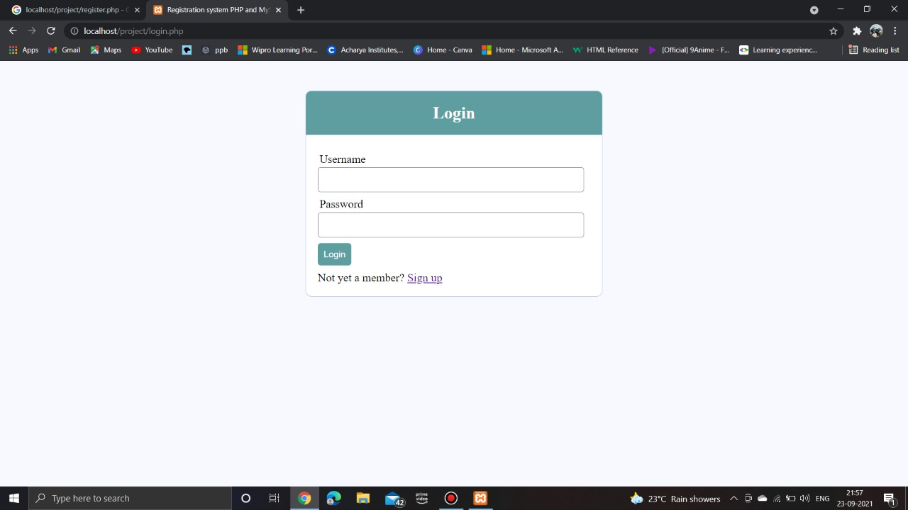

FIG1: LOGIN PAGE

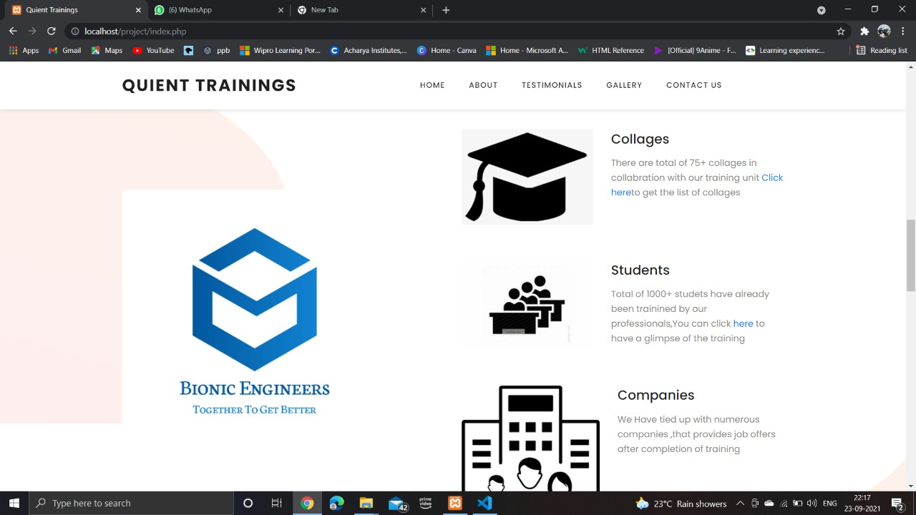

FIG2: LANDING PAGE

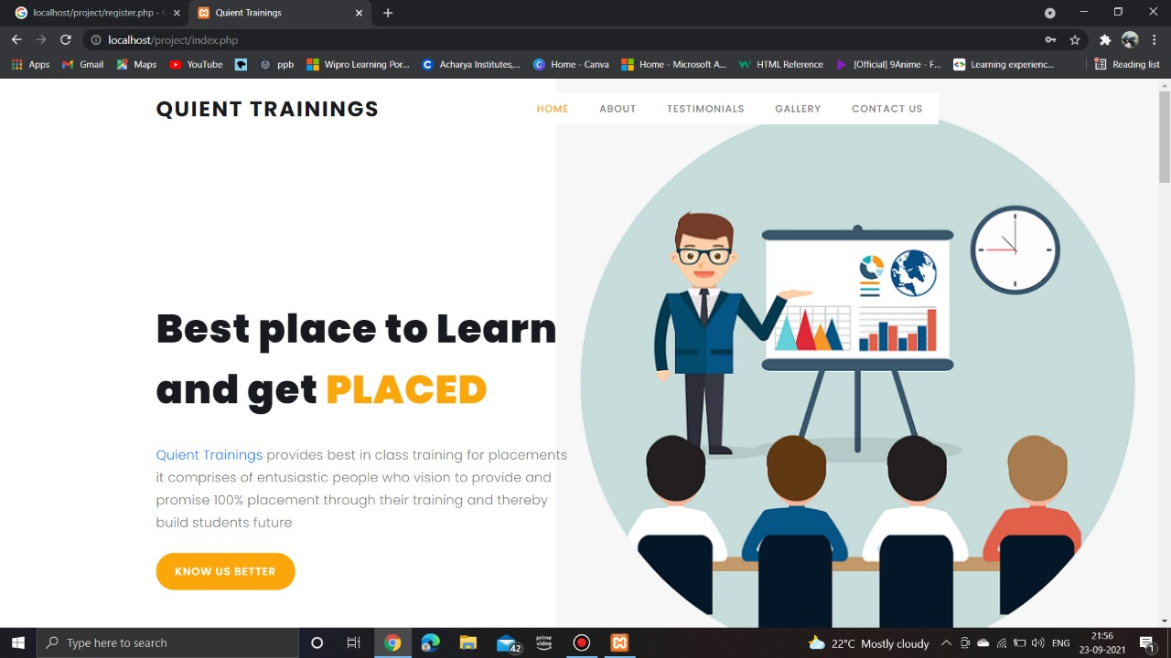

FIG3: HOME PAGE

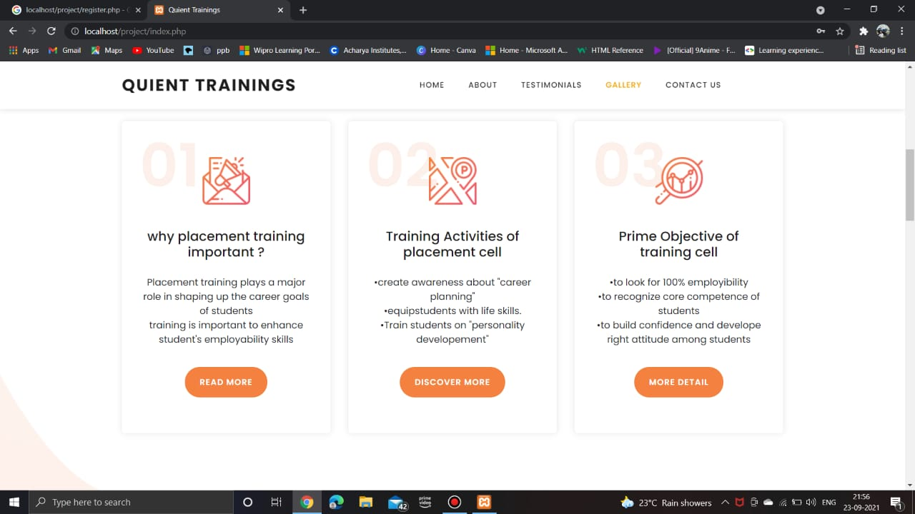

FIG3: GALLERY PAGE

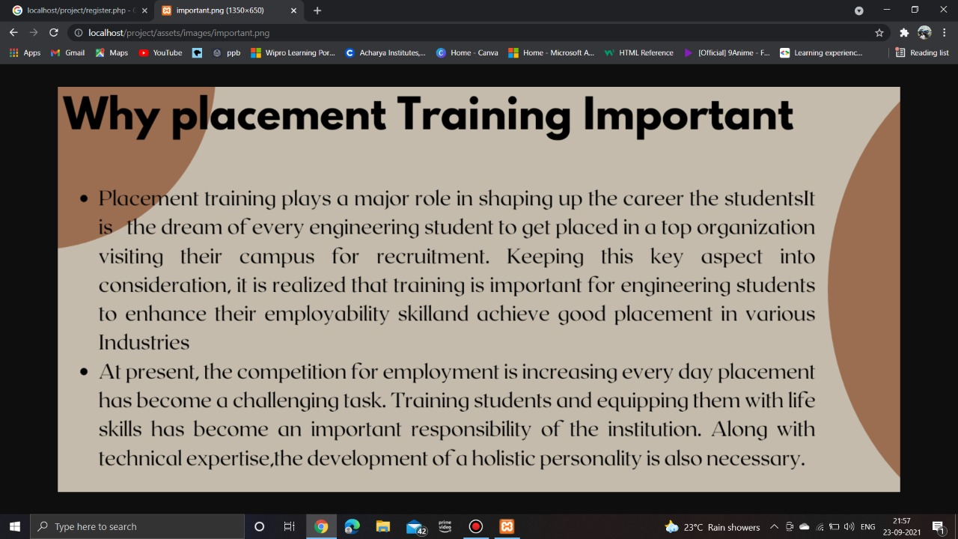

FIG3.1: IMPORTANCE OF PLACEMENT TRAINING

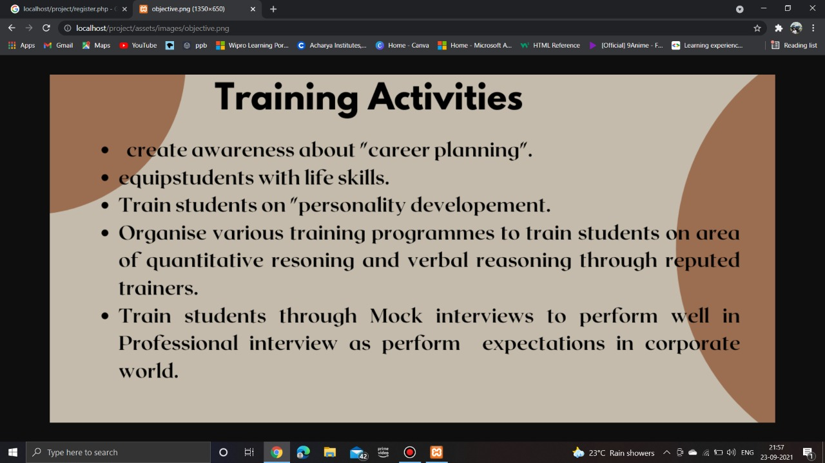

FIG3.2: TRAINING ACTIVITIES

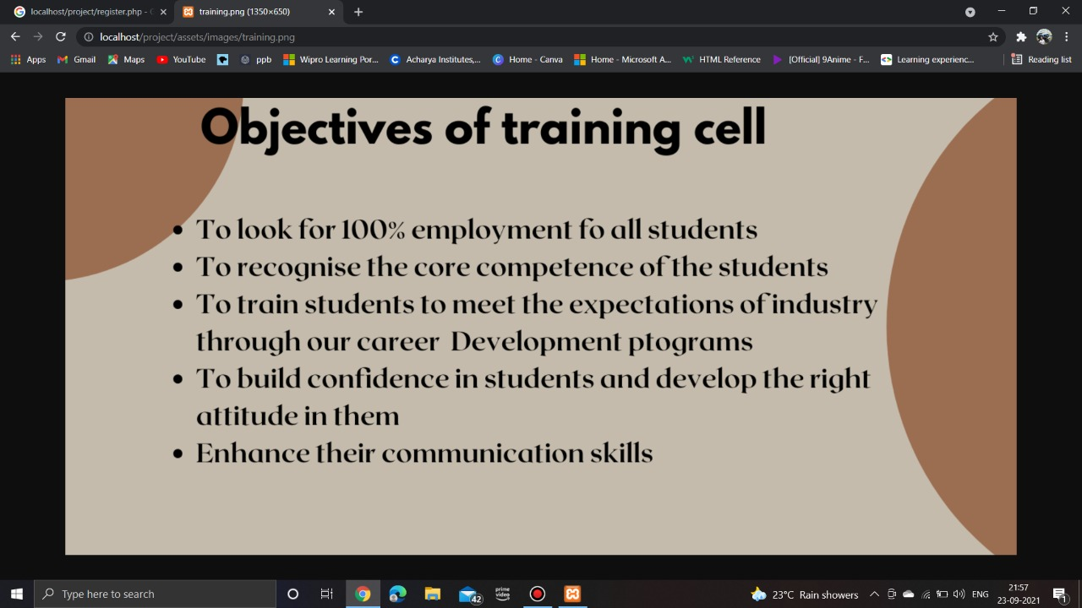

FIG3.3: OBJECTIVES OF TRAINING CELL

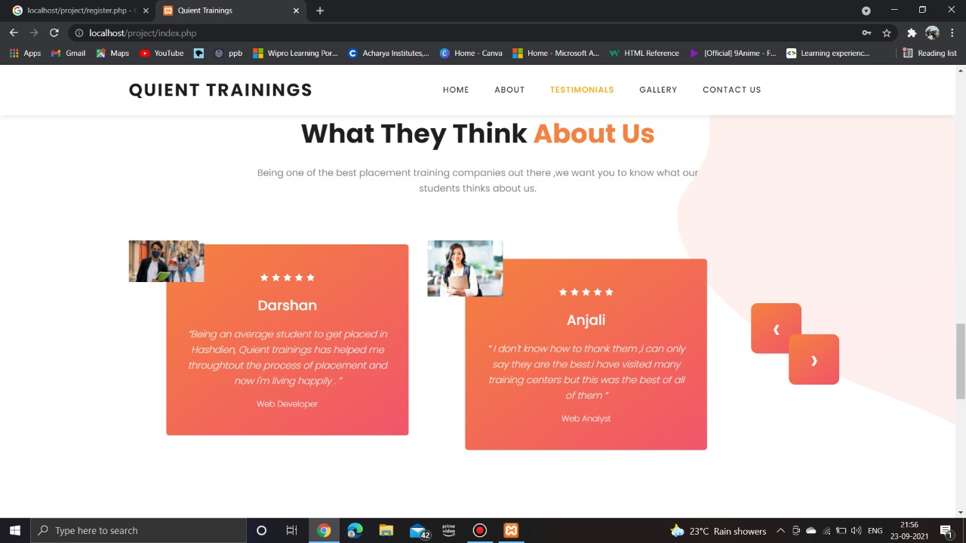

FIG4: TESTIMONALS

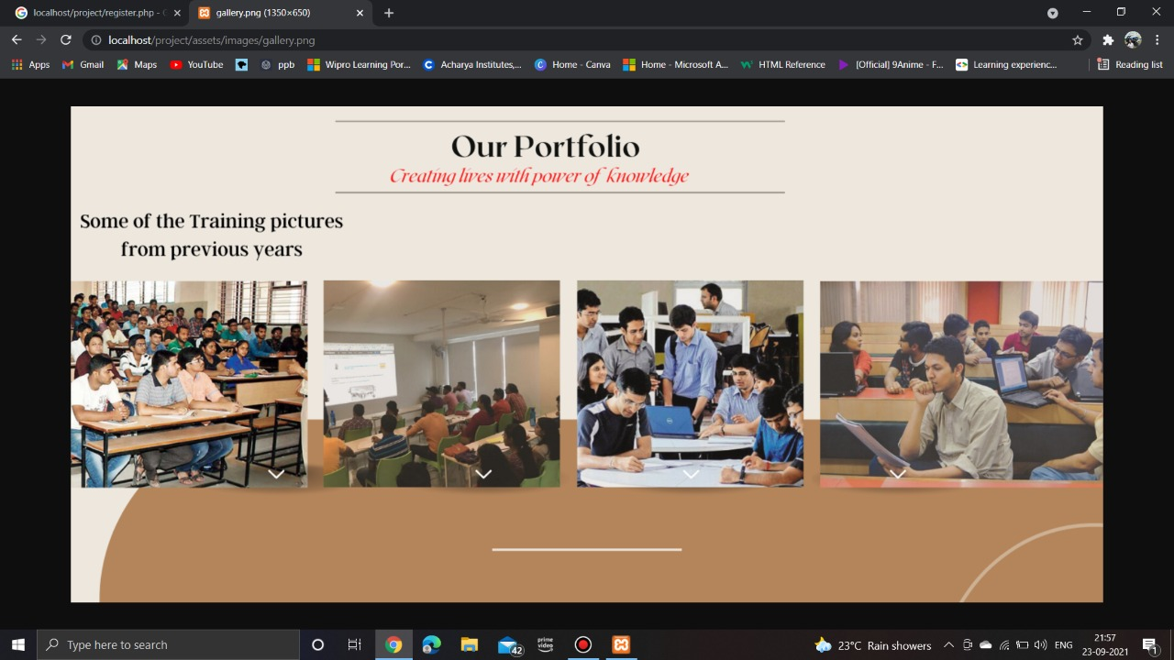

FIG5: PORTFOLIO

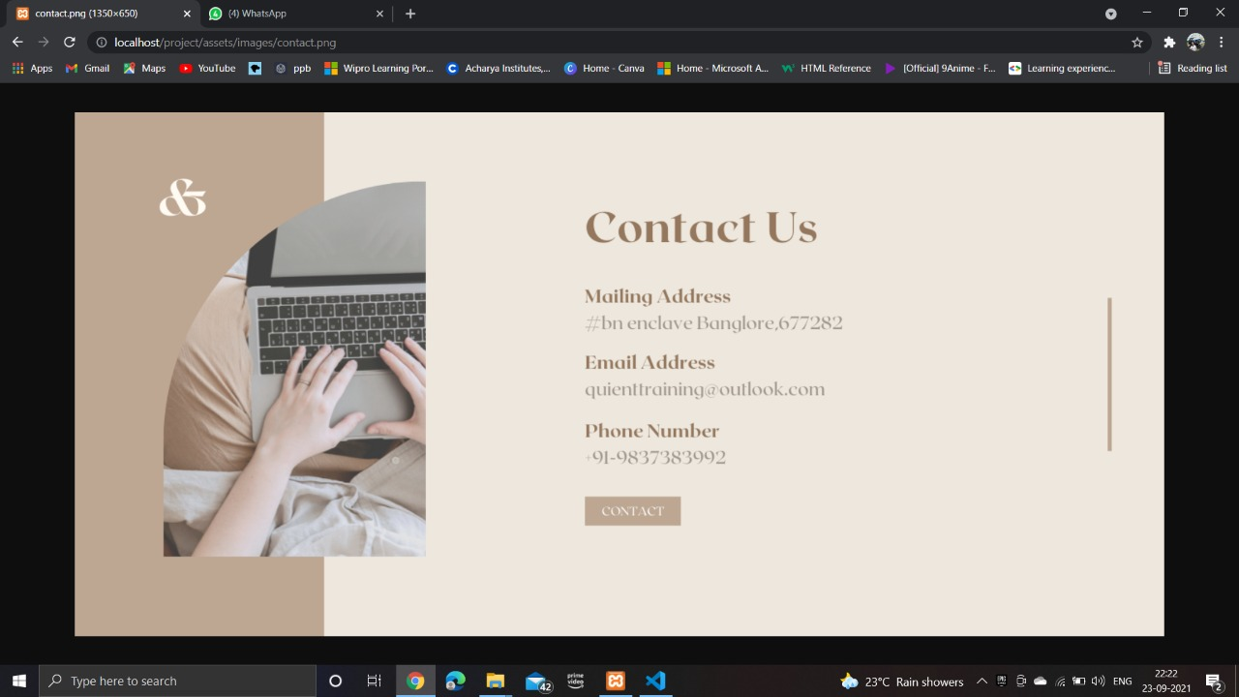

FIG6: CONTACT US

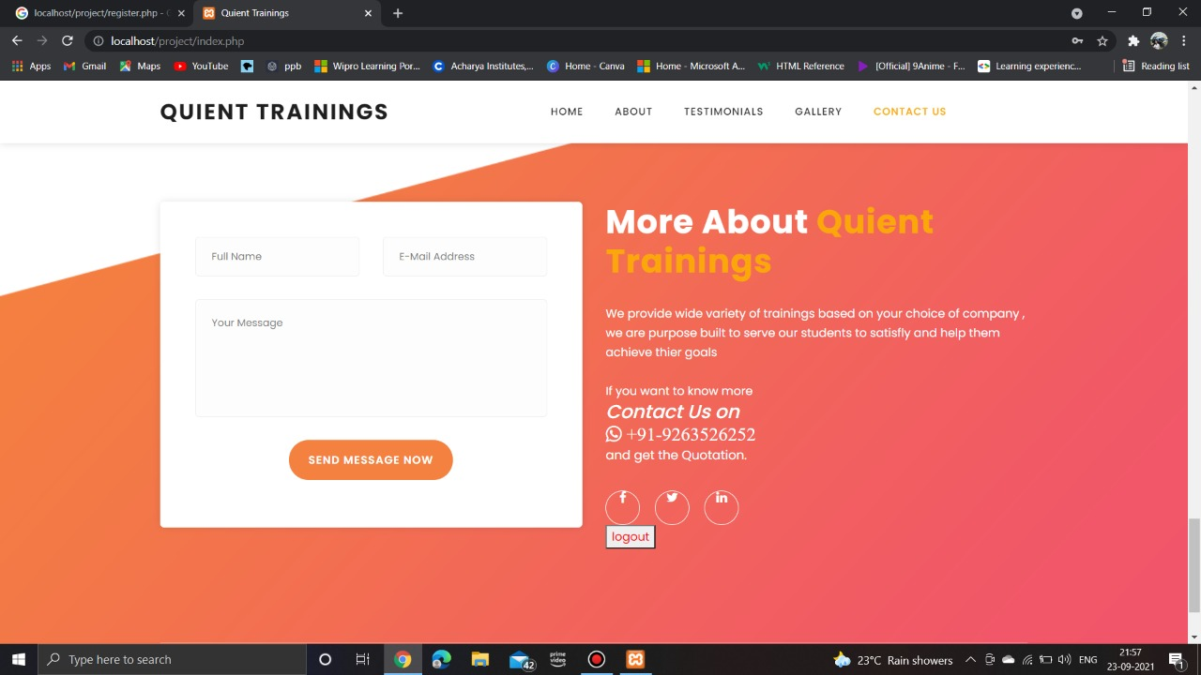

FIG7: LOGOUT

**BIBLIOGRAPHY**

* https://[www.w3schools.com](http://www.w3schools.com/)
* https://[www.geeksforgeeks.org](http://www.geeksforgeeks.org/)
* <https://freefrontend.com>

## **About my TEAM**

## Team work allows people to share and combine ideas so offers the chance for members to support each other in achieving a task or goal. It was a very nice experience working with our team mates (Chaitra V, Chandana M, Sree Rakshitha Lahari) , we gained information about project everyone gave their own ideas in making the project, from each one we collected the points and we did the project. Thank you